

**Diagnostic Evidence Co-operative (DEC) Newcastle**

Evaluation of the two-step testing strategy for familial hypercholesterolaemia

Authors

NIHR Diagnostic Evidence Co-operative Newcastle upon Tyne, UK, NE2 4HH  
Joy Allen  
IVD evaluation methodologist  
  
Michael Power  
deputy director

# Abstract

## Background

## Objectives

## Methods

## Results and discussion

# Introduction

AHSN dataset

The study recruited 258 index cases i.e. people assessed as likely to have a mutation for

familial hypercholesterolaemia (FH).

## Demographic data

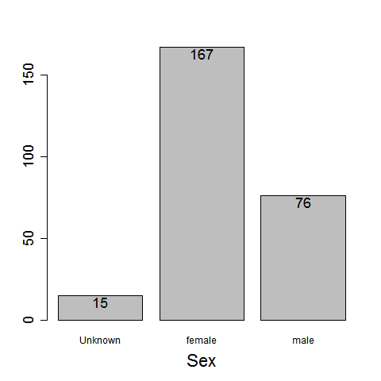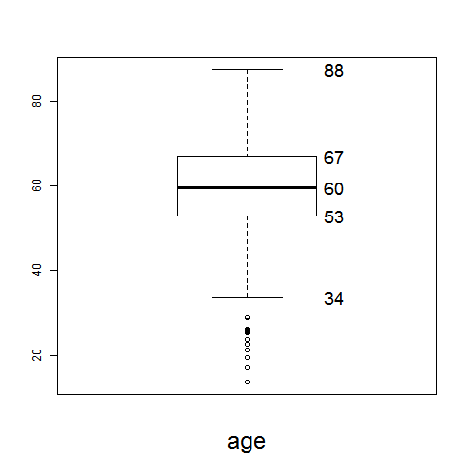

### Physical Scoring

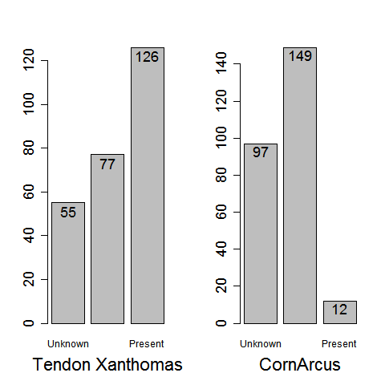

### Personal History

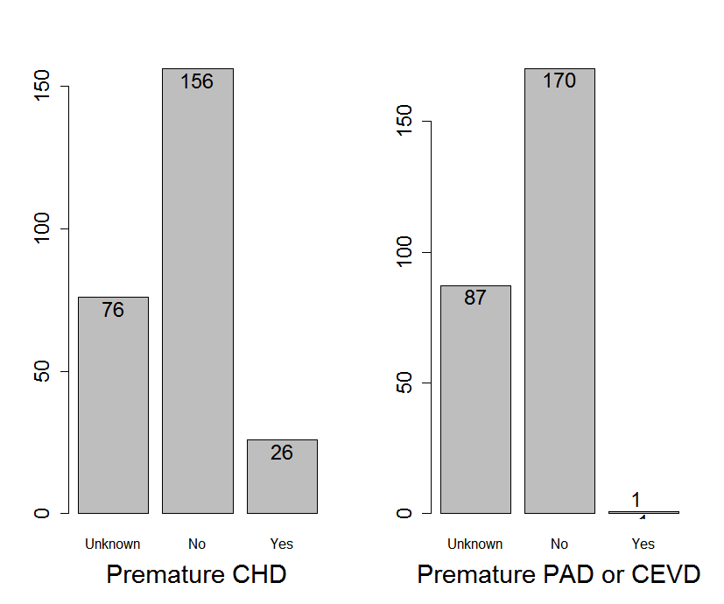

### Relatives at risk

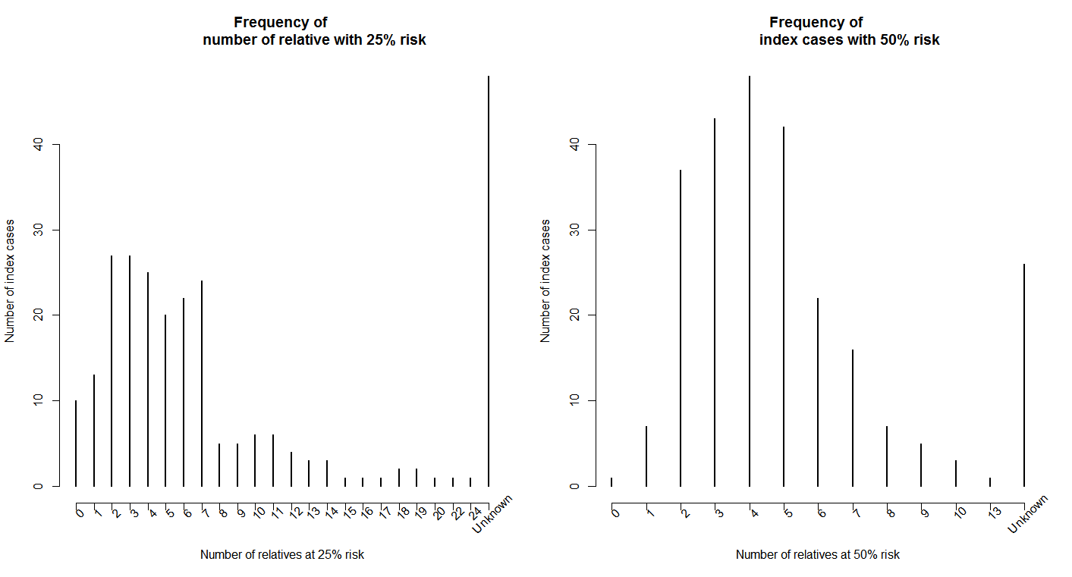

|  |  |  |  |  |  |  |  |  |  |  |  |  |  |  |  |  |  |  |  |  |  |  |  |  |
| --- | --- | --- | --- | --- | --- | --- | --- | --- | --- | --- | --- | --- | --- | --- | --- | --- | --- | --- | --- | --- | --- | --- | --- | --- |
| Number of relatives at risk | 0 | 1 | 2 | 3 | 4 | 5 | 6 | 7 | 8 | 9 | 10 | 11 | 12 | 13 | 14 | 15 | 16 | 17 | 18 | 19 | 20 | 22 | 24 | Unknown |
| 50% | 1 | 7 | 37 | 43 | 48 | 42 | 22 | 16 | 7 | 5 | 3 | 0 | 0 | 1 | 0 | 0 | 0 | 0 | 0 | 0 | 0 | 0 | 0 | 26 |
| 25% | 10 | 13 | 27 | 27 | 25 | 20 | 22 | 24 | 5 | 5 | 6 | 6 | 4 | 3 | 3 | 1 | 1 | 1 | 2 | 2 | 1 | 1 | 1 | 48 |

### Fasting LDL cholesterol with triglycerides <2.3

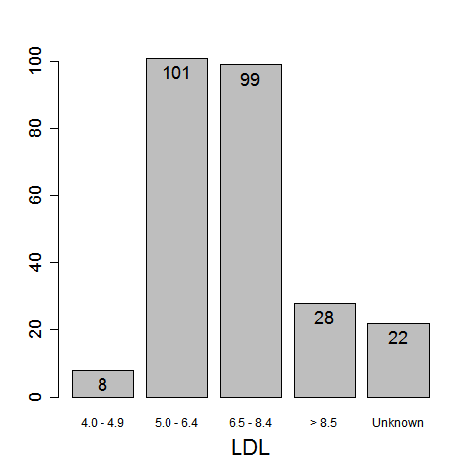

### Dutch Lipid Clinic Network Score

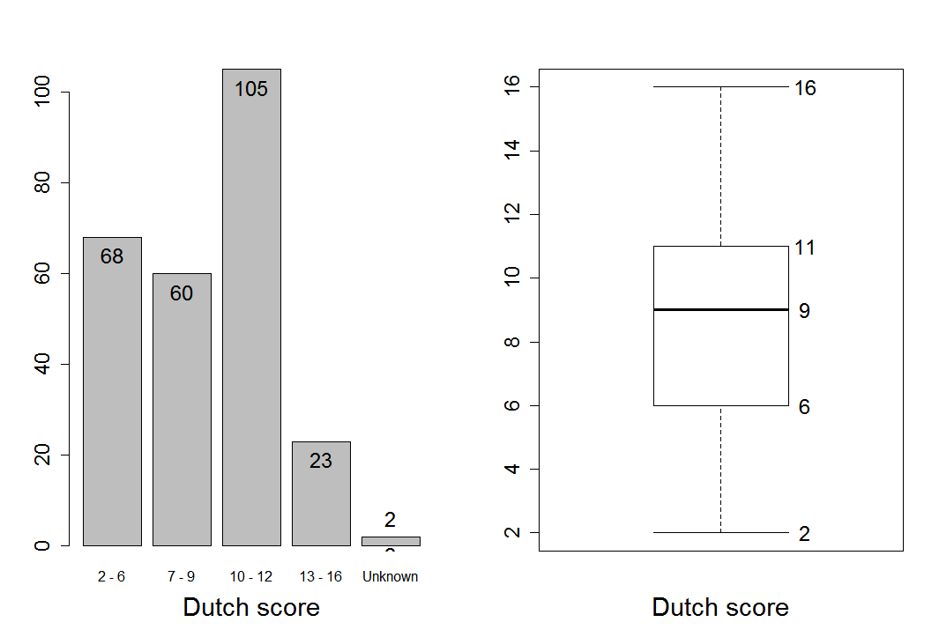

### Fasting lipid profile results used for diagnosis

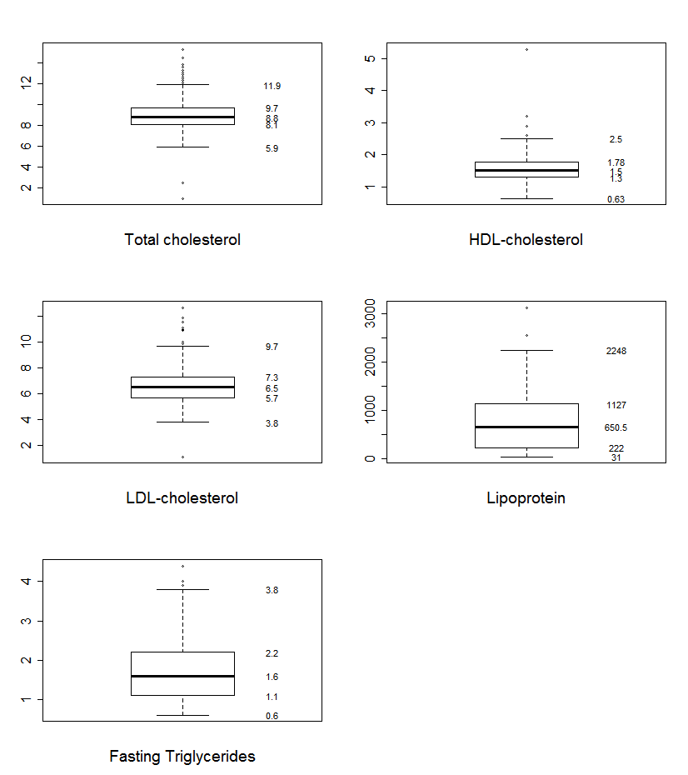

## Testing

The study recruited 258 people likely to have a mutation familial hypercholesterolaemia (FH). Figure 1 shows the testing pathway for the index cases.

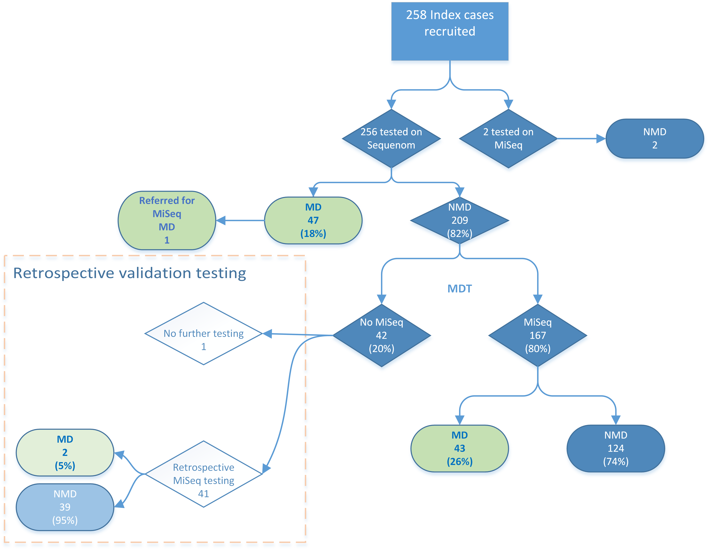

Figure 1 Flow of index cases through the two stage testing pathway. Retrospective validation testing was carried out to determine the accuracy of the two stage testing strategy.

Of the 258 index cases, 257 were tested with the muliplexed SNP genotyping (Sequenom). One was immediately tested with next generation sequencing on the basis of the Multidisciplinary team’s (MDT) decision and no mutation associated with FH was detected.

Of the 257 tested with the Sequenom, 47 (18%) were found to have a mutation known to be associated with FH.

The MDT reviewed the remaining 210 cases and recommended that 168 of these cases were tested using next generation gene sequencing, of which 43 (26%) were found to have a mutation.

Table 1 summarises the index cases results.

Table 1 Summary of testing results



## Accuracy of testing algorithm

To assess the accuracy of the two stage testing process, 41 of the remaining 42 index cases were retrospectively tested for a mutation and it was found that 2 index cases with mutations associated with FH were missed (as indicated by the retrospective validation testing box in Figure 1).

Accuracy of the two step testing process – 2x2 table

|  |  |  |  |
| --- | --- | --- | --- |
|  | | **Mutation present** | **Mutation absent** |
| 2 step testing | **MD** | 90 | 0 |
| **NMD** | 2 | 164 |
|  | | 92 | 164 |

Sensitivity = 97.8% (95% CI: 96.0% - 99.6%)

Specificity = 100%

Two stage testing pick-up rate = 35%

Prevalence = 36%

## Cost analysis

The cost per patient for the two step testing strategy was £358.14, which represents a saving of £41.86 per patient when compared with a testing strategy using MiSeq testing only.

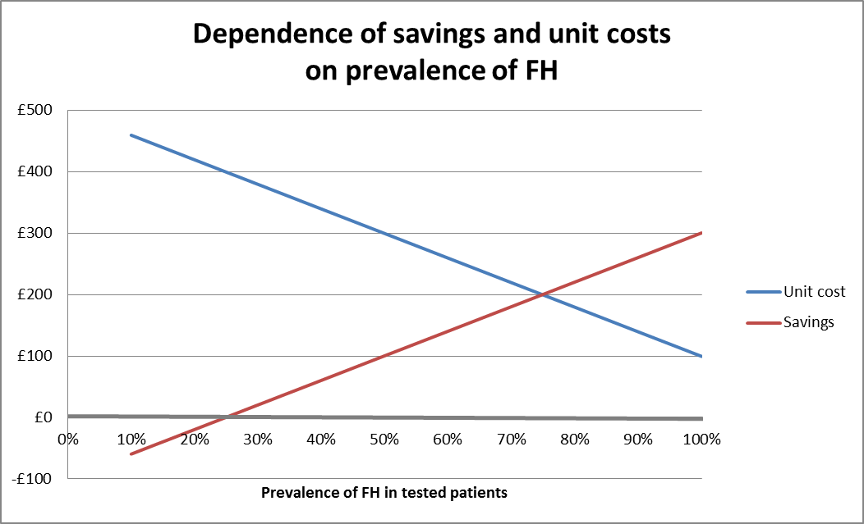

Figure 2 Cost and saving per index case tested; figure shows an increase in the cost savings of the two step testing strategy as the number of mutation positives increase.

Figure 2 shows that the two-step testing strategy is cost-saving at a prevalence greater than 25%, and that the savings increase as the prevalence increases.

The percentage of index cases found to have mutation in this study was 35%. The prevalence was 36%.

## Potential opportunities for refining the two-step testing strategy

Opportunities originally identified for further efficiency improvements were

1. scoring physical signs of hypercholesterolaemia,
2. taking account of the effect of age on lipid levels,
3. validating MDT assessments,
4. risk scoring for polygenic hypercholesterolaemia - gene sequencing would not be indicated with high LDL SNP score relative to measured LDL-C,
5. reducing the number of mutations which are not reported frequently on UK PASS

database,

1. adapting the set of mutations used in Sequenom testing as the prevalences of mutations in populations of interest becomes better known.

We now look at some of these variables these individually to assess whether there is a correlation between them and the presence of an FH mutation.

1. Scoring physical signs of hypercholesterolaemia

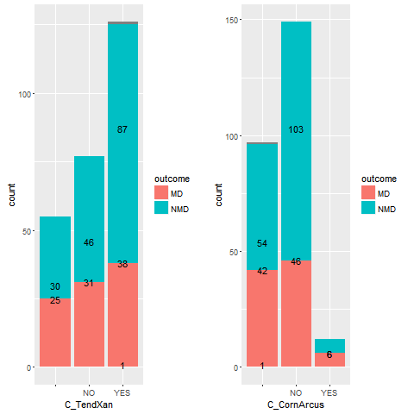

Patients are selected for proband testing on the basis of their Dutch Lipid Clinic Network

Score (DLCNS). The DLCNS might be able to more accurately reflect the risk of carrying an FH mutation if physical signs were scored and the confounding effects of age were reduced.

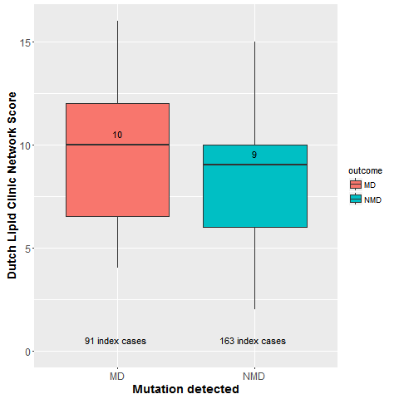

Figure 3 Boxplot of index test Dutch Lipid Clinic Network Score stratified by presence of absence of mutation.

Coefficients for Univariate logistic regression analyses for predicting outcome of interest: Mutation present or not.

|  |  |  |  |  |  |
| --- | --- | --- | --- | --- | --- |
|  | **n** | **Beta** | **CI** | **OR** | **p-value** |
| *Age* | 257 | 0.0274 | (0.0076,0.0479) | 1.0278 (1.0077,1.0491) | 0.007451178 |
|  |  |  |  |  |  |
| *Sex* | 242 |  |  |  |  |
| Female | 167 | 0.5785 | (0.2664,0.9) | 1.7833 (1.3053,2.4596) | 0.000334828 |
| Male | 75 | -0.1171 | (-0.6765,0.4505) | 0.8895 (0.5084,1.5691) | 0.682919237 |
|  |  |  |  |  |  |
| *Dutch Score* | 254 | -0.1573 | (-0.2566,-0.0624) | 0.8545 (0.7737,0.9395) | 0.001439765 |
|  |  |  |  |  |  |
| *Tendon Xanthomas* | 202 |  |  |  |  |
| Absent | 77 | 0.3947 | (-0.056,0.8589) | 1.4839 (0.9455,2.3605) | 0.089438826 |
| Present | 125 | 0.4337 | (-0.1617,1.0289) | 1.5429 (0.8507,2.798) | 0.152355496 |
|  |  |  |  |  |  |
| *Corneal Arcus* | 161 |  |  |  |  |
| Absent | 149 | 0.8061 | (0.4653,1.1623) | 2.2391 (1.5925,3.1973) | 5.48E-06 |
| Present | 12 | -0.8061 | (-2.0173,0.404) | 0.4466 (0.133,1.4978) | 0.181992299 |
|  |  |  |  |  |  |
| *TotalC* | 239 | -0.7466 | (-1.0078,-0.5137) | 0.474 (0.365,0.5983) | 2.83E-09 |
|  |  |  |  |  |  |
| *LDLC* | 229 | -0.7525 | (-1.0277,-0.5065) | 0.4712 (0.3578,0.6026) | 1.40E-08 |
|  |  |  |  |  |  |
| *nonhdl* | 234 | -0.6987 | (-0.9528,-0.4718) | 0.4972 (0.3857,0.6239) | 1.13E-08 |
|  |  |  |  |  |  |
| *Trigly* | 228 | 0.5559 | (0.1734,0.9662) | 1.7435 (1.1893,2.6279) | 0.005805617 |
|  |  |  |  |  |  |
| *MoM* | 234 | -2.6273 | (-3.6001,-1.7606) | 0.0723 (0.0273,0.1719) | 1.98E-08 |

Age, Dutch score, TotalC, LDLC, nonhdl, Trigly and MoM are all statistically significant predictors of outcome.

Beta, the logistic regression coefficient gives the change in log odds of the outcome for one unit increase in the predictor variable.

E.g. For every one unit chance in the Ducthscore, the log odds of the outcome –MD changes by -0.1573.

## Roc curves for univariate analysis

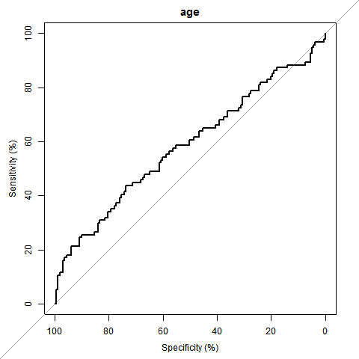

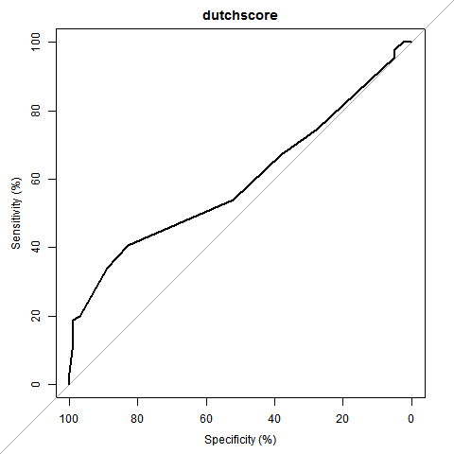

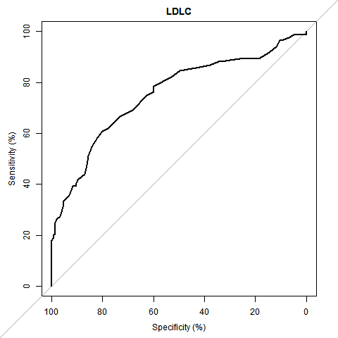

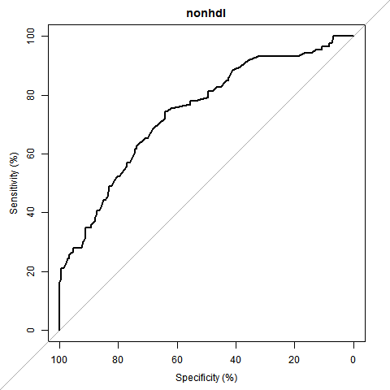

## Z:\DEC methods\tools - R\Working_project_folders\NCL_DEC0002 Familial hypercholesterolaemia\Current2016-2017\figures\ahsn\Apr20161212rocTrigly.png

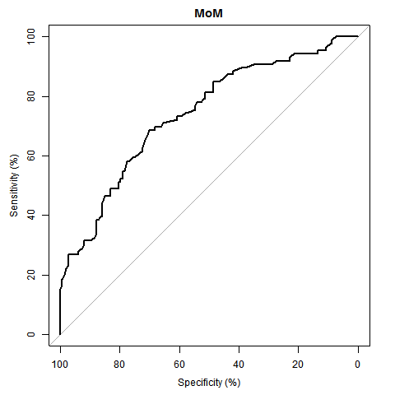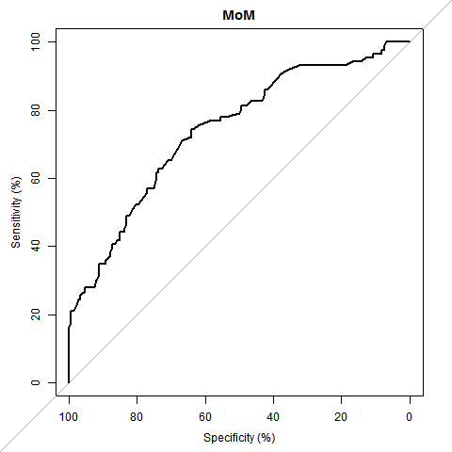

|  |  |  |  |  |  |
| --- | --- | --- | --- | --- | --- |
| **Variable** | **Deviance** | **AIC** | **auroc** | **Lower CI** | **Upper CI** |
| age | 330.0890825 | 334.0890825 | 0.583670539 | 0.508276157 | 0.659064922 |
|  |  |  |  |  |  |
| dutchscore | 320.6579649 | 324.6579649 | 0.59519315 | 0.518133722 | 0.672252579 |
|  |  |  |  |  |  |
| TotalC | 262.5221244 | 266.5221244 | 0.757221718 | 0.694791885 | 0.819651551 |
|  |  |  |  |  |  |
| LDLC | 255.9455079 | 259.9455079 | 0.753078818 | 0.684425392 | 0.821732244 |
|  |  |  |  |  |  |
| nonhdl | 262.1093685 | 266.1093685 | 0.741200503 | 0.675053648 | 0.807347358 |
|  |  |  |  |  |  |
| Trigly | 292.8415455 | 296.8415455 | 0.630316742 | 0.551205335 | 0.709428149 |
|  |  |  |  |  |  |
| LDL | 265.080386 | 273.080386 | 0.722920243 | 0.660314301 | 0.785526186 |
|  |  |  |  |  |  |
| MoM | 263.4461 | 267.4461 | 0.738686 | 0.672325 | 0.805048 |

## Break down of variables in Dutch Score

## Attempts to reduce the MDT negative hit rate.

## Application of centiles to the data

# Discussion

# References

# Figures

# Tables

|  |  |
| --- | --- |
| Total number of patients recruited | 258 |
| Sequenom testing | |
| Index cases undergoing Sequenom testing | 256 |
| Mutation detected on Sequenom (MD) | 47 |
| No mutation detected on Sequenom (NMD) | 209 |
| Total cost of Sequenom testing | £25,600 |
| MiSeq testing | |
| Index cases with NMD on Sequenom, undergoing MiSeq | 167 |
|  |  |
| Index cases with NMD on Sequenom and MD on MiSeq | 43 |
| Index cases with NMD on both Sequenom and MiSeq | 124 |
| Total cost of MiSeq testing | £66,880 |
| **Total cost of testing** | **£92,400** |

Table 2 Number of index cases undergoing testing for FH

|  |  |
| --- | --- |
| Percentage MD index cases detected on Sequenom | 18% |
| Percentage of NMD on Sequenom who testing MD by MiSeq | 26% |
| Percentage of index cases found to have a mutation | 35% |

Table 3 Percentage of index cases testing positive for a mutation associated with FH

|  |  |
| --- | --- |
| **Mutation** | **Frequency of detection** |
| ABOB c.10580G>A p.(Arg3527Gln) | 9 |
| LDLR c.1048C>T p.(Arg350\*) | 1 |
| LDLR c.1187-10G>A | 1 |
| LDLR c.1359-31\_1359-23delinsCGGCT | 3 |
| LDLR c.1444G>A p.(Asp482Asn) | 9 |
| LDLR c.1444G>C p.(Asp482His) | 1 |
| LDLR c.1463T>G p.(Ile488Ser) | 1 |
| LDLR c.1897C>T p.(Arg633Cys) | 5 |
| LDLR c.2054C>T p.(Pro685Leu) | 5 |
| LDLR c.259T>G p.(Trp87Gly) | 1 |
| LDLR c.301G>A p.(Glu101Lys) | 1 |
| LDLR c.313+1G>A | 2 |
| LDLR c.326G>A p.(Cys109Tyr) | 2 |
| LDLR c.660delC p.(Asp221Thrfs\*44) | 1 |
| LDLR c.662A>G p.(Asp221Gly) | 1 |
| LDLR c.681C>G p.(Asp227Glu) | 1 |
| LDLR c.682G>T p.(Glu228X) | 2 |
| LDLR c.932\_933delAA p.(Lys311Argfs\*) | 1 |
| NMD | 209 |
| NOT DONE | 2 |
| Total | 258 |

Table 4 Index case mutation hits detected by Sequenom testing

|  |  |  |
| --- | --- | --- |
| **Mutation** | **Frequency of detection** | **Point of detection** |
| APOB c.10397C>A p.(Ser3466Tyr) | 1 |  |
| ApoB c.10740C>T p.(Asn3580Asn) - VUS | 1 |  |
| APOE c.239C>A p.(Ala80Glu) | 1 |  |
| ApoE c.492\_493delinsCT p.(Lys164\_Arg165delinsAsnTrp) - VUS | 1 |  |
| LDLR c.1019\_1020delinsTG, p.(Cys340Cys) | 1 |  |
| LDLR c.1060G>A p.(Asp354Asn) | 1 |  |
| LDLR c.1072T>C p.(Cys358Arg) | 1 |  |
| LDLR c.1211C>T p.(Thr404Ile) | 1 |  |
| LDLR c.1246C>T p.(Arg416Trp) | 1 |  |
| LDLR c.1318A>G p.(Arg440Gly) | 2 |  |
| LDLR c.1371\_1374dup p.(Ala459fs) | 1 |  |
| LDLR c.1478\_1479dup p.(Val494fs) | 1 |  |
| LDLR c.1486C>T p.(Agr496Trp) | 1 | Retrospective MiSeq testing after MDT decision for no further testing |
| LDLR c.1567G>A p.(Val523Met) | 1 | Retrospective MiSeq testing after MDT decision for no further testing |
| LDLR c.1618G>A p.(Ala540Thr) | 1 |  |
| LDLR c.1684\_1686dup p.(Trp562dup) | 1 |  |
| LDLR c.1730G>A p.(Trp577\*) | 1 |  |
| LDLR c.1764C>G p.(Ile588Met) | 1 |  |
| LDLR c.1816G>T p.(Ala 606Ser) | 1 |  |
| LDLR c.1876G>A p.(Glu626Lys) | 1 |  |
| LDLR c.1943C>T p.(Ser658Phe) | 1 |  |
| LDLR c.2043C>A p.(Cys681\*) | 2 |  |
| LDLR c.2088C>A p.(Cys696\*) & PCSK9 c.-331C>A | 1 |  |
| LDLR c.2140+1G>A | 1 |  |
| LDLR c.2389G>A p.(Val797Met) | 1 |  |
| LDLR c.2412G>A p.(Leu804Leu) | 1 |  |
| LDLR c.257delT p.(Phe86fs) | 1 |  |
| LDLR c.302A>G p.(Glu101Gly) | 1 |  |
| LDLR c.326G>A p.(Cys109Tyr) | 1 | Found on both Seq and MiSeq |
| LDLR c.501C>A p.(Cys167\*) | 2 |  |
| LDLR c.502G>A p.(Asp168Asn) | 2 |  |
| LDLR c.532G>T, p.(Asp178Tyr) | 1 |  |
| LDLR c.564C>G p.(Tyr188\*) | 1 |  |
| LDLR c.621C>T p.Gly207Gly | 1 |  |
| LDLR c.663\_683dup p.(Asp221\_Asp227dup) | 1 |  |
| LDLR c.685G>T p.(Glu229\*) | 1 |  |
| LDLR c.694+3\_694+19del | 1 |  |
| LDLR c.862G>A, p.(Glu288Lys) | 1 |  |
| LDLR c.912C>G p.(Asp304Glu) & LDLR c.2096C>T p.Pro699Leu) | 1 |  |
| LDLR c.938\_939delinsAT p.(Cys313Tyr) | 2 |  |
| PCSK9 c.113A>G p.(Tyr38Cys) | 1 |  |
| **Total** | **46** |  |

Table 5 Index case mutation hits detected by MiSeq testing

## Appendix: Results of two stage testing strategy from full dataset n= 414

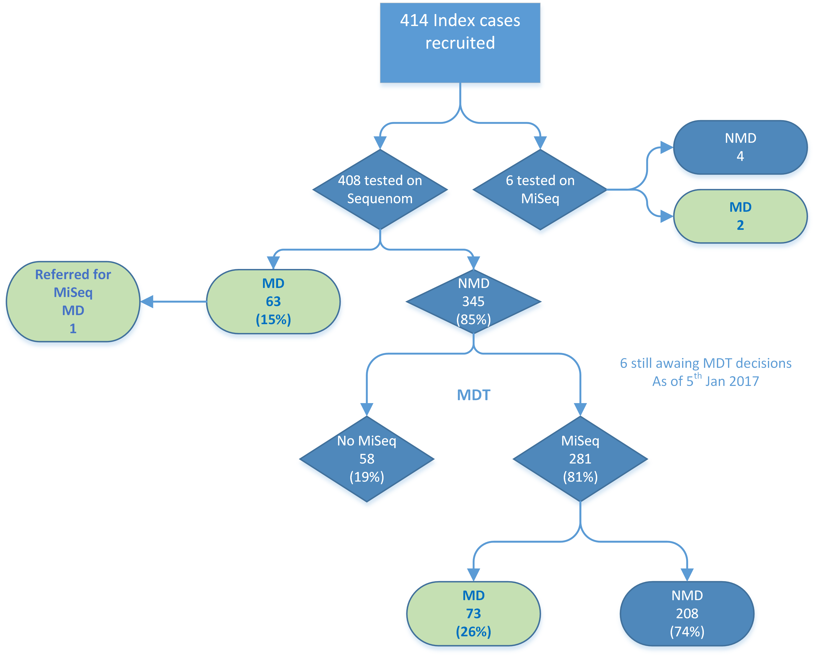

Of the 414 index cases, 411 were tested with the muliplexed SNP genotyping (Sequenom),

which identi\_ed a mutation in 63 (15%).

Of the 281 index who were tested with next generation gene sequencing (MiSeq) and whose

results were available, 73 (26%) had a mutation known to be associated with FH.

The cost per patient for the two step testing strategy was £370.77, which represents a

saving of £29.23 per patient when compared with a testing strategy using MiSeq testing

only.

The prevalence of mutation positive index cases (probands) was 33%.

|  |  |
| --- | --- |
| Total number of patients recruited | 414 |
| Sequenom testing | |
| Index cases undergoing Sequenom testing | 408 |
| Mutation detected on Sequenom (MD) | 63 |
| No mutation detected on Sequenom (NMD) | 345 |
| Total cost of Sequenom testing | £41,100 |
|  |  |
| MiSeq testing | |
| Index cases with NMD on Sequenom, undergoing MiSeq | 281 |
|  |  |
| Index cases with NMD on Sequenom and MD on MiSeq | 73 |
| Index cases with NMD on both Sequenom and MiSeq | 208 |
| Total cost of MiSeq testing | £112,400 |
|  |  |
| **Total cost of testing** | **£153,500** |

|  |  |
| --- | --- |
| Percentage MD index cases detected on Sequenom | 15% |
| Percentage of NMD on Sequenom who testing MD by MiSeq | 26% |
| Percentage of index cases found to have a mutation | 33% |